PRODUCT REQUEST FORM
PRODUCT NAME: | 70% Isopropyl Alcohol (IPA) Spray
DESCRIPTION OF REQUEST:  - New Product  - Modification  - Product Extension  - Country addition  - Label Change  - Intended Use  -…Etc… | Establishing a strategic distribution partnership to supply 70% Isopropyl Alcohol (IPA) Spray from a leading U.S. manufacturer. This product further solidifies our commitment to becoming a comprehensive one-stop service distributor for the compounding pharmacy market.  Project Background  In the $15.6 billion U.S. compounding pharmacy market, maintaining USP <797> and <800> compliance is paramount. Beyond pre-wetted wipes for precise cleaning, Surface and equipment disinfection within cleanrooms and anterooms requires a reliable, ready-to-use spray solution. 70% IPA Spray is a foundational consumable for this purpose, used extensively for sanitizing large work surfaces, equipment exteriors, and carts.  As with the wipes, developing or sourcing this product from regions with complex regulatory pathways contradicts our agile, service-oriented distributor strategy. Therefore, distributing a trusted, U.S.-manufactured 70% IPA Spray is the optimal path. This move:  - Strengthens our “Compliance Essentials” portfolio, allowing us to offer a complete disinfection solution.  - Accelerates our market credibility by leveraging a partner’s established regulatory standing and quality reputation.  - Deepens client reliance by addressing another high-volume, recurrent need within their workflow.  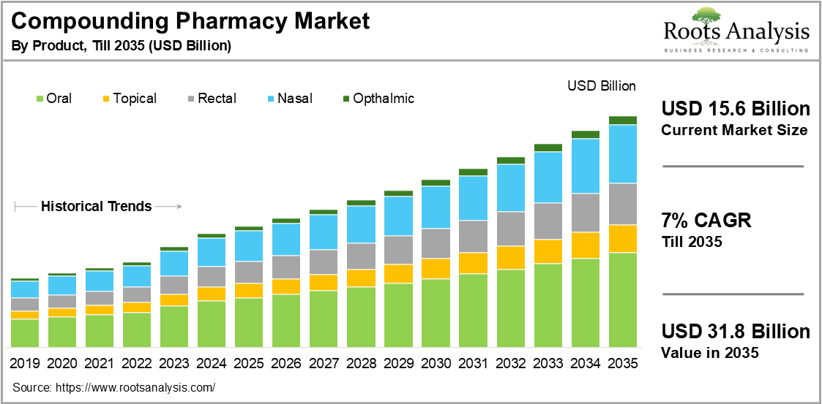
PURPOSE OF REQUEST: | ☐Complaint No. ☐Supplier ☒New market_______US_________  ☐Customer ___ ☐Internal _ ☐Other________________________  Add details:
ESTIMATED BENEFITS: | ☒ Financial Benefit:___Complete the product lines for the Compounding Pharmacy markets, Annual sales amount 500K ____ (Mandatory For NPD request)  Estimate the potential increase in cash flows, revenues, or any other financial benefits  ☐ Cost Saving:__________  Decrease in the cogs, transportation or operation expenses, or any other cost-saving opportunities  ☐ Improved Operational Efficiencies:_________  Decrease in the Lead time, delivery time, MOQ, Inventory, or any other efficiency improvement  ☐ Non-Financial Benefits:_________  Quality Improvement; Enhanced customer satisfaction, product competition, Brand reputation, etc.  ☐ Other Benefits:__________
PRODUCT DESCRIPTION:  - Functional performance requirements  - Appearance  - Any unique points of differentiation against similar competitor product lines  . ..Etc… | Product Definition & Scope 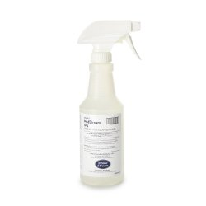  This project defines a new distribution partnership to augment our service offering.  - Product: 70% Isopropyl Alcohol Spray, in compliant sizes (e.g., 1-gallon bottles with sprayers, or ready-to-use spray bottles) from a qualified U.S. partner.  - Primary Use: For broad-surface disinfection in compounding pharmacy cleanrooms, anterooms, and on equipment, supporting environmental control protocols.  - Our Role: We will source, stock, and distribute this product, integrating it into our logistics and sales platform to provide pharmacies with a convenient, reliable source for both their spray and wipe disinfection needs.  Agent Brand Proposal  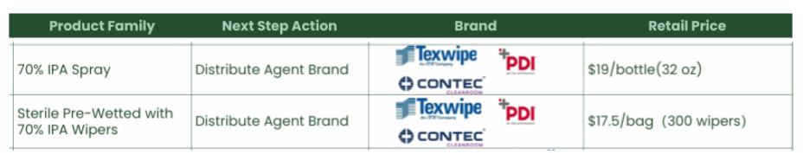
REQUEST TYPE | ☐LCR (Labelling Change Request)  Changes on the labels without changing the products  ☐SCR (Supplier Change Request)  Change applications initiated by Suppliers  ☐ECR (Engineering Change Request)  Existing products that SOLM is the legal manufacturer  Engineer changes that are not bringing new hazards/risks  ☐NPD (New Product Development)  Develop new innovative products that SOLM will be the legal manufacturer  Significant changes on existing products that may bring new hazards/risks or new intended use  Change products from outsourcing to SOLM to be the legal manufacturer  Development of VET/Component products  ☒SDP (SOLM Distributor Product)  New product introduction that SOLM will not be the legal manufacturer  No change on the product, no SOLM information on the labels  ☐SPP (SOLM Portfolio Product)  New product introduction that SOLM will not be the legal manufacturer  No change on the product, Add SOLM information on the labels  ☐Customized Product / Market  Purchased products that SOLM is not the legal manufacturer  Engineering change on products or new customized products requested by SOLM  New Market region requested by SOLM
TARGET MARKET: | ☒ US ☐ Canada ☐ EMEA ☐ UK ☐ Brazil ☐ Australia & New Zealand ☐ Other countries/regions, list:
TARGET USE: | ☒ Human Use  ☐ Animal Health | STERILE | ☐ YES  ☒ NO
VOLUME/SALES OPPORTUNITY: | Launch volume required: | Yr 1 estimate | Yr 2 estimate
CUSTOMER NOTIFICATION | Do we have any special quality agreement in place with customer which requires approval before implementing changes? ☐ YES ☒ NO  If Yes, please provide the customer's name and evidence.  Attach the customer confirmation GF-0083 at the end of the form.  Is notification to the customers needed after change project is closed? ☐ YES ☒ NO  Remark:  Example: change affect regulatory, performance, appearance, etc. Notification method.
LEGAL MANUFACTURER: | ☐ Sol-Millennium  ☒ Other: __________ | BRANDING | ☒ Sol-Millennium  ☐ Private Label
EXPECTED PRODUCT LAUNCH PERIOD: | ☒ < 1 year  ☐ 1-3 year  ☐ > 3 years | EXPECTED PRODUCT LIFE PERIOD: | 10 years
NAME AND DATE of REQUEST: | Alex Lu 2026/1/30

